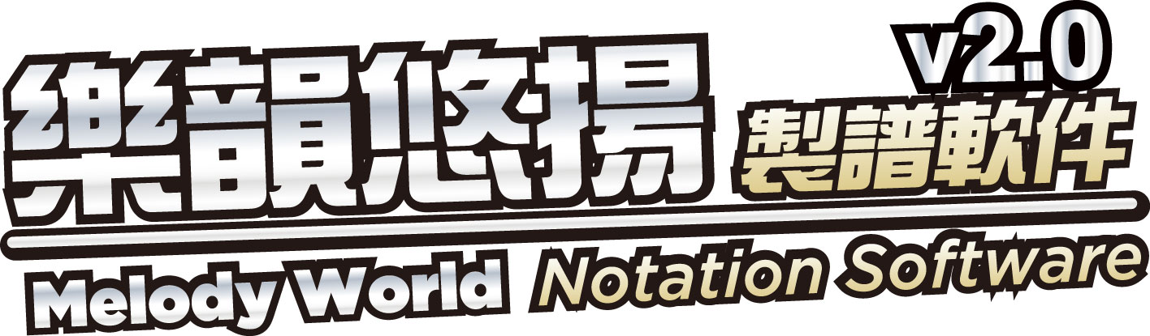

~Welcome to Melody World~
Notation Software V2.0 ( English Version )

This year activation password (Trail Version):

2012-EU5P-F38P-RQSA
Expiry Date: 2012-7-31

