Journey of Computer Literacy for Secondary School (Modular Course) ①
Module | Corrigenda
Integration of Text and Graphics | 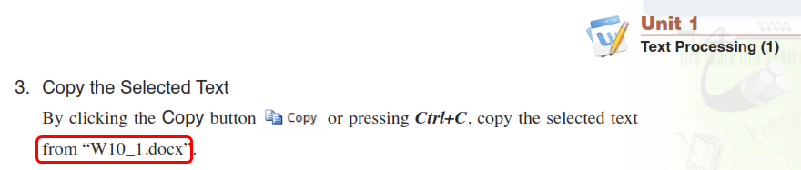  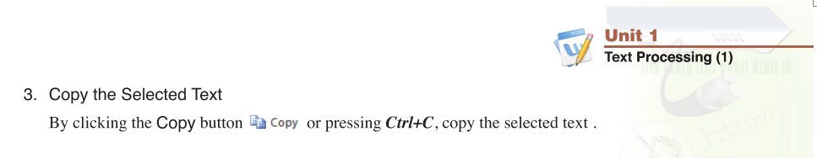  (P.9) Delete the encircled portion.  Corrected version
Basics of Computers and Computer Operation | (P.22) Replace all the occurrences of “Home” (encircled in red) with “Flat” and delete “Shelves” (encircled in green)  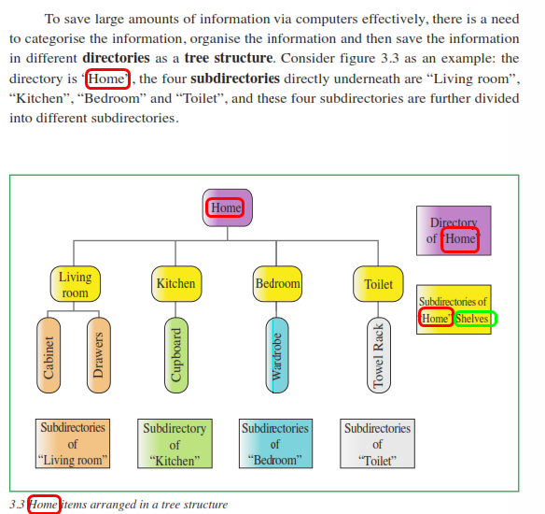  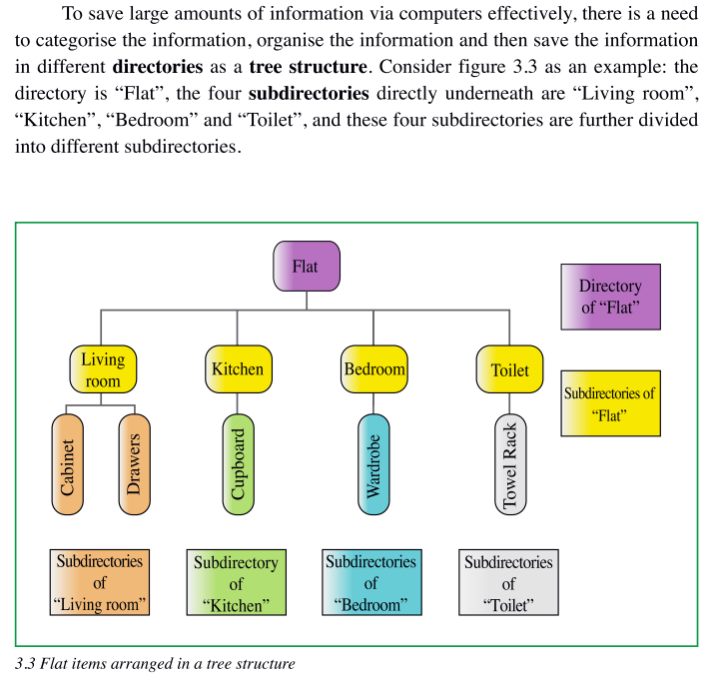  Corrected version
Journey of Computer Literacy for Secondary School (Modular Course) ②
Module | Corrigenda
Components of a Computer System and Computer Software | 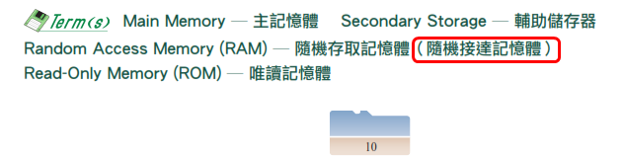  (P.10) Delete the encircled portion.  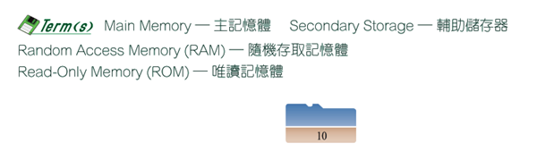  Corrected version  (P.35) Delete the encircled portion.  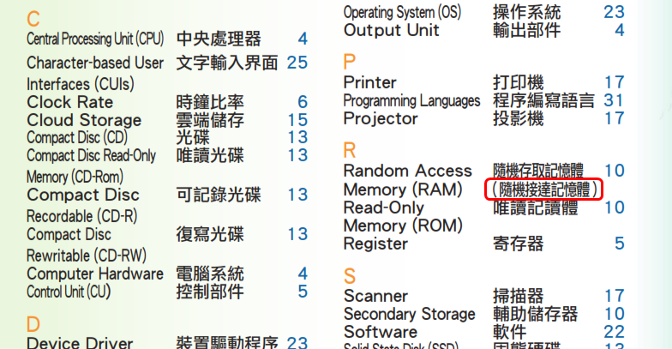  Corrected version  